PURULIA POLYTECHNIC
IT LABORATORY REPORT
NAME:

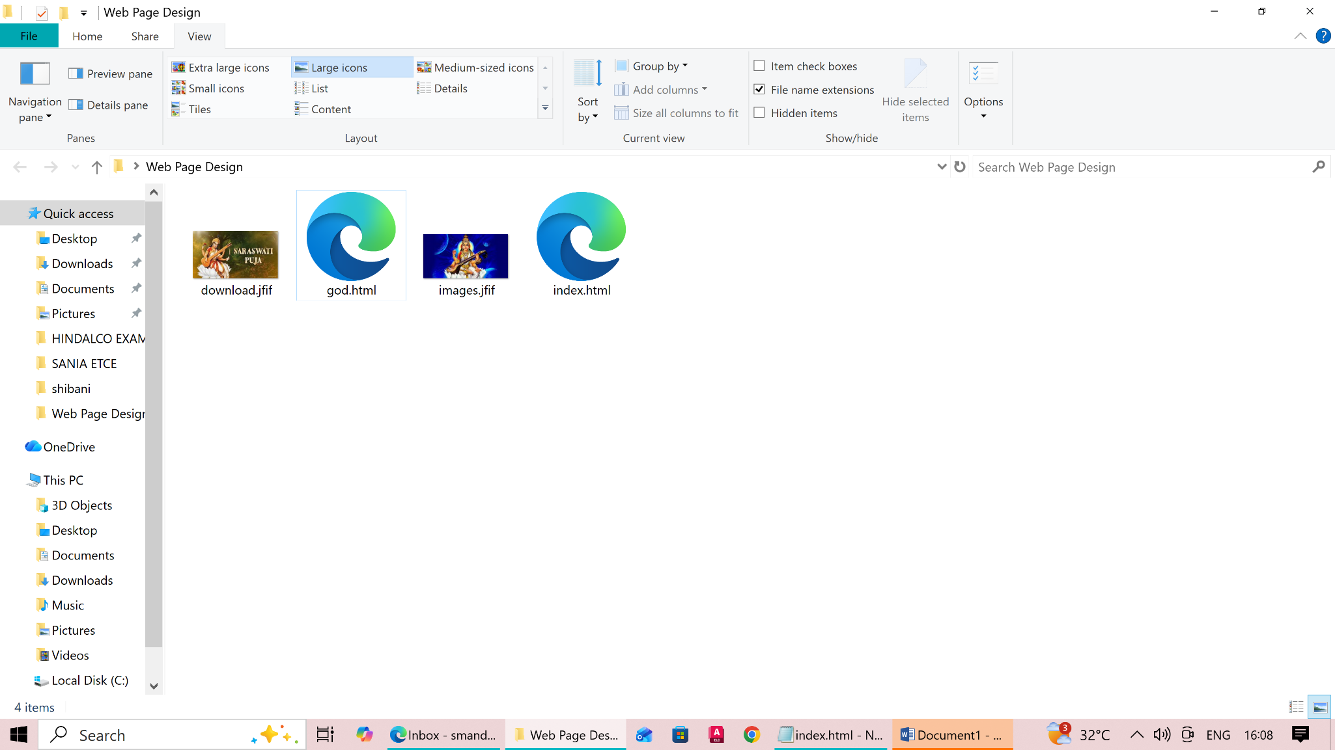
File Structure:
Structure:

HTML Code:
File Name: index.html
<html>

<head>
<title> Home Page</title>
</head>

<body>
<h1 align="center">Welcome to Purulia Polytechnic</h1>
<a href="god.html">Goddess Saraswati</a>
<br>
<a href="https://google.com">Google</a>
<br>
<a href="https://facebook.com">facebook</a>
</body>

</html>

<html>

<head>
<title> God Page</title>
</head>

<body>
<a href="index.html">Return to Home Page</a>
<MARQUEE DIRECTION="RIGHT" scrollamount="20">
<h1 align="center">Happy Saraswatiu Puja 2026</h1>
</MARQUEE>

<img src="download.jfif"></img>

<MARQUEE DIRECTION="LEFT" scrollamount="20">
<h1 align="center">Happy Saraswatiu Puja 2026</h1>
</MARQUEE>
</body>

</html>

File Name: god.html
